**ENTRY FORM**

To enter the Congress online, follow the instructions at [www.stalbanscongress.com](http://www.stalbanscongress.com). Alternatively, please fill in the postal entry form below.

Full Name

Address

Postcode

Home Tel. No

Email

Current ECF Grade ECF Code

ECF Membership No Level

Date of Birth (for juniors or veterans)

Club/School

Tournament entered

½ point bye in round? (not in round 5)

Entry fee £

(£5 discount for players

under 18 on 31/8/2014)

ECF “pay to play” fee (see note to right) £

Additional fees £

* Late fee - £3 (for entries
* postmarked after 21/3/2015)
* Telephone entry - £5
* Entry on the day - £5 (before 9.30)

Donation, thank you £

**Total amount due £**

Please make cheques payable to “St Albans Chess Congress”.

Please enclose a stamped, addressed envelope if a reply is required for (tick as appropriate):

Receipt of entry ☐ Accommodation list☐

**RULES**

**Times of play 5 Round Swiss Tournaments**

Saturday R1. 10:00 R2. 14:30 R3. 18:30

Sunday R4. 10.00 R5. 14:30

Prize giving asap after the end of round 5

**ECF “Pay to Play” Fees**

This is a registered ECF Game Fee event.  Players who are not current ECF Members at Silver, Gold or Platinum level on the date of entry will have £6 (£4 for Juniors) added to their entry fee.

Bronze ECF members should note that their membership will be upgraded to Silver by the ECF following processing of the congress results for grading.

Upgrading prior to the congress – online or via the ECF office – is recommended.

**General Information**

1. The Chief organiser is Ray Claret. The organisers reserve the right to refuse entries, transfer entries, and to revise prize money, according to circumstances.
2. If your opponent has not arrived 30 minutes after the start of a round s/he is defaulted and you should report to the Controller’s desk.
3. A ½ point bye may be requested in advance, except in round 5.
4. Refunds will not be granted for non-appearance.
5. Except in the OPEN, no ungraded player may win more than a maximum of £40. However, to be eligible for this prize money they must have provided written evidence of their playing strength, before Sunday 22nd March 2015.
6. No smoking is allowed in the school, or its grounds.
7. The Arbiter’s is decision in all matters is final.
8. We regret that wheelchair access to this venue is difficult.

This event is organised by St. Albans Chess Club

[**www.stalbanschessclub.org.uk**](http://www.stalbanschessclub.org.uk)

St Albans Chess Club welcomes players of all ages and playing strength

We meet on Mondays at the **County Club, 29 Ridgmont Road, St Albans, AL1 3AG**, just a short walk from St Albans City railway station.

Early Knights Juniors from 6.30 to 7.30pm and the Seniors from 7.30pm onwards

For further details contact Ray Claret on

07802 419545 or email [**enquiries@stalbanschessclub.org.uk**](mailto:enquiries@stalbanschessclub.org.uk)

|  |  |
| --- | --- |
|  |  |
|  |  |

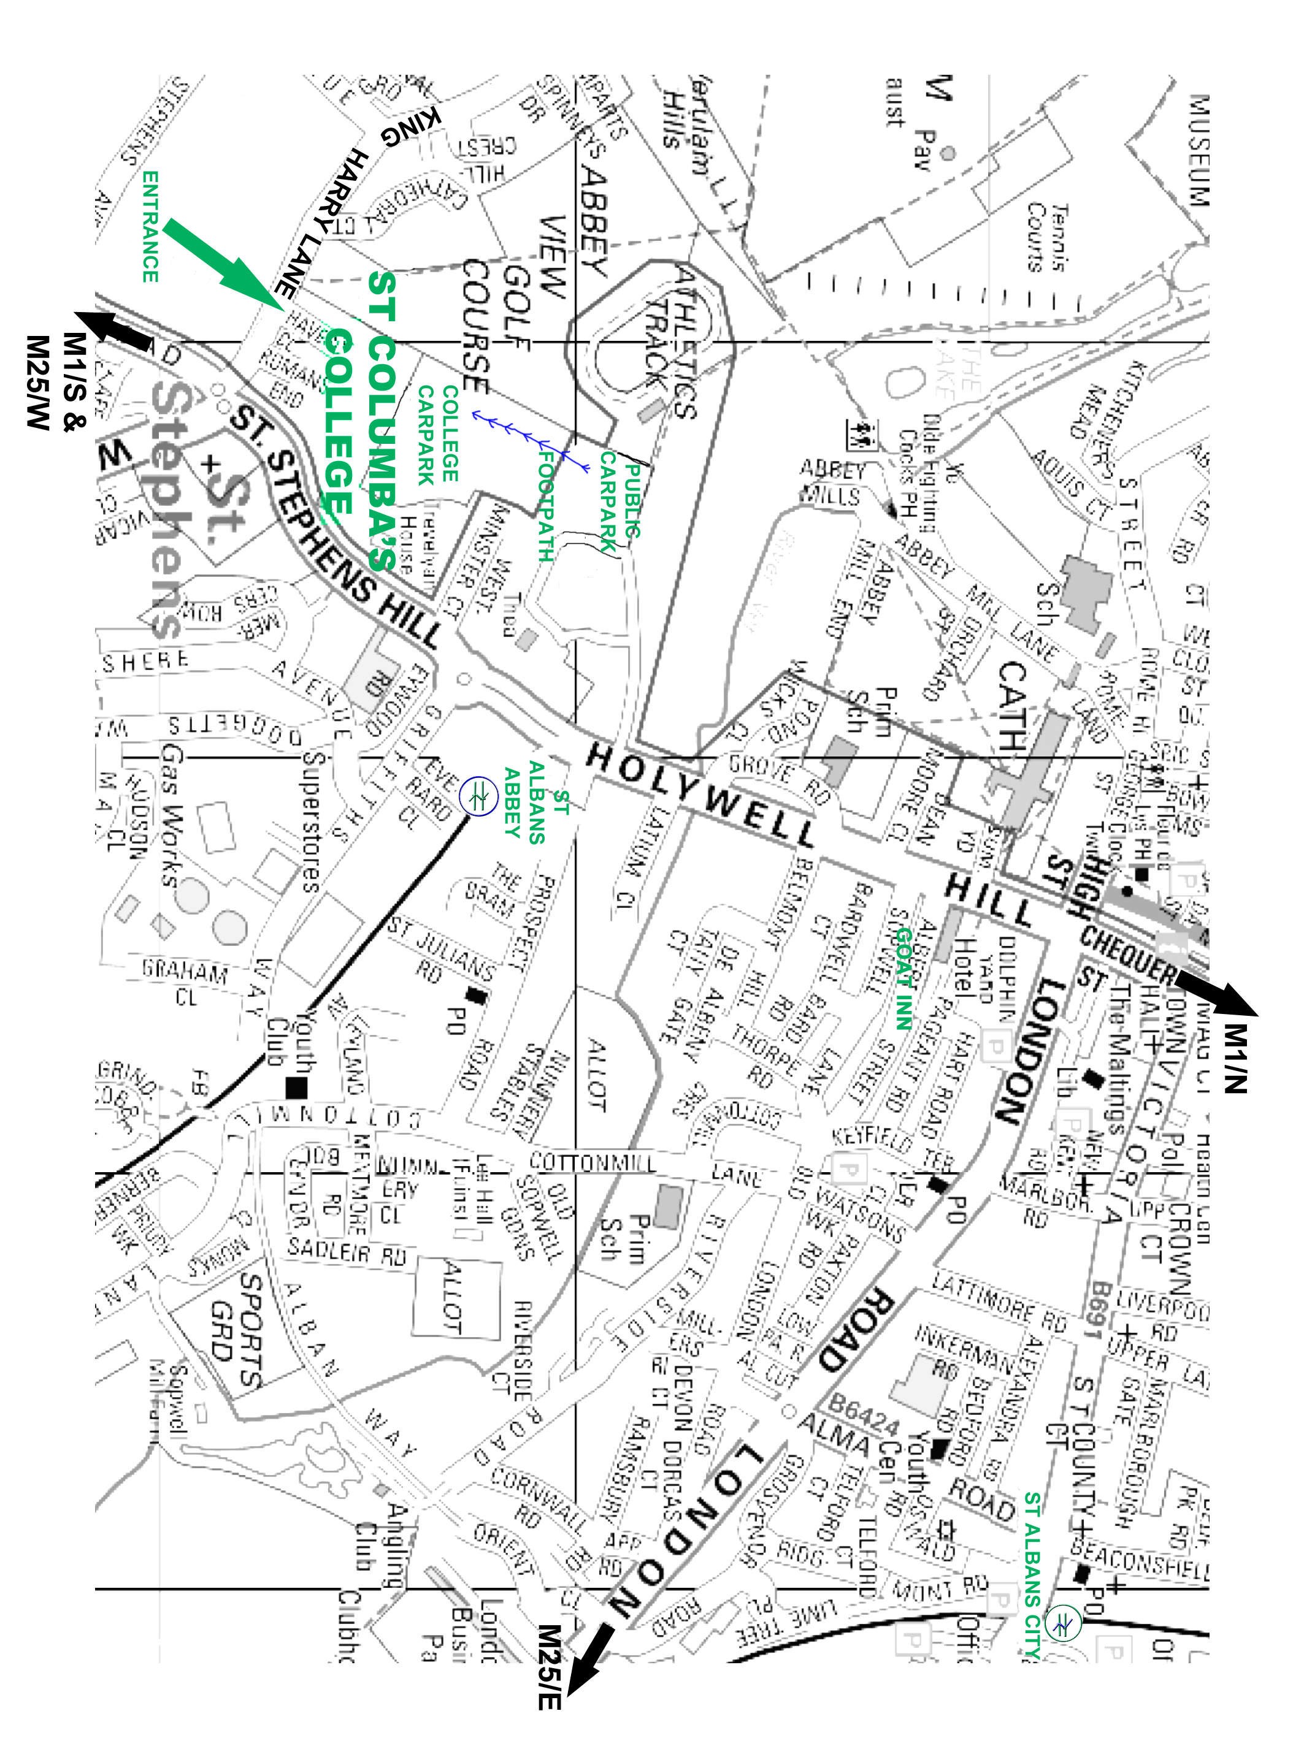

St Columba’s College, King Harry Lane,

St Albans, AL3 4AW. 28th+29th March.

|  |
| --- |
| TOURNAMENTS* |
|  |  |  |  |  |
| *Eligibility determined by grade on 27/3/2015 |  |  |  | | |  |
| **Open Entry Fee £32\*\***  No grade limits  Prizes £320 £160 £80  Grading Prize for players below 185 £60 |  |  |  | | |  |
|  |  |  |  | | |  |
| **Challengers Entry Fee £27\*\***  For players graded 180 and below  Prizes £270 £135 £70 + Grading Prize £30 |  |  |  | | |  |
|  |  |  |  | | |  |
| **Major Entry Fee £27\*\***  For players graded 160 and below  Prizes £270 £135 £70 + Grading Prize £30 |  |  |  | | |  |
|  |  |  |  | | |  |
| **Intermediate Entry Fee £27\*\***    For players graded 140 and below  Prizes £270 £135 £70 + Grading Prize £30 |  |  |  | | |  |
|  |  |  |  |  |
| **Minor Entry Fee £27\*\***  For players graded 120 and below  Prizes £270 £135 £70 + Grading Prize £30 |  |  |  |  |
| **\*\* £5 DISCOUNT FOR PLAYERS UNDER 18 \*\*** |  |  |  | | |  |
| **Other Prizes**  For best performance by a junior under 14 £40  Veterans Prize (age over 65) £40  Age on 31.8.2014 determines qualification.  **Rate of Play**   * 36 moves in 90 minutes * 30 moves in 75 minutes for re-paired games   Unfinished games will be decided by a 15 minute quick play finish.  ***www.chessengland.com***  **Under 2200 (200 ECF) FIDE Rated Congresses** Every month, in Hampstead and Golders Green [**hampsteadchess.blogspot.co.uk**](http://WWW.hampsteadchess.blogspot.co.uk)[**goldersgreenchessweekender.blogspot.co.uk**](http://www.goldersgreenchessweekender.blogspot.co.uk)    **www.chessengland.com** |  |  |  | | |  |
|  |  |  | | |  |
|  |  |  | | |  |

***THE GOAT INN***

is St. Albans Chess Club’s summer venue, and less than 15 minutes walk from the Congress.

Comfortable B&B at reasonable rates

An award winning pub with a great selection of real ales, fine wines, home-made food, and live music.

37 Sopwell Lane, St.Albans.AL11RN

email mail@goatinn.co.uk Telephone 01727 833934

***CHESSandBRIDGE.com***

**The London Chess Centre at 44 Baker Street, London. W1U 7RT. Telephone:- 0207 486 7015** is Europe’s biggest chess shop and chess resource. We stock everything you need to learn or enjoy the game. Our range of gifts is second to none.

33rd St Albans

Chess Congress 2015

**Saturday 28th– Sunday 29th March**



**Sponsored by**

**Chess and Bridge**

**St. Columba's College**

King Harry Lane, St Albans AL3 4AW

With ample parking for 200+ cars

**\*Massive playing hall for 250 competitors\***

Close to M1 & M25

Thameslink & Watford Junction trains

Food & drink available

Eligible for ECF Grand Prix 2014/15

**Over £2700 in prizes**

**Veteran, Junior, and grading prizes**

Entry Forms, fees & enquiries to:

Terry Douse,

c/o 23 Westfields, St. Albans, Herts. AL3 4LR

Telephone: 01727 751072

**email: stalbanscongress@yahoo.co.uk**